**AI Story Maker Final Report**

**Pipeline**

The pipeline constitutes the most important part of this project. The pipeline is the black box which takes a user input and create a movie. It does so in 8 different steps which are outlined below

* We use **Mistral AI (mistral-medium)**, a powerful large language model (LLM) developed in France, to generate engaging and coherent stories based on user input (Figure 1). Users can provide a simple prompt—such as *“Create a story about a battle between Zeus and Poseidon”*—and Mistral AI will generate a detailed narrative aligned with the theme. The more specific the prompt, the more closely the generated story will reflect the user’s intent. Alternatively, if users already have a story written, they may input it

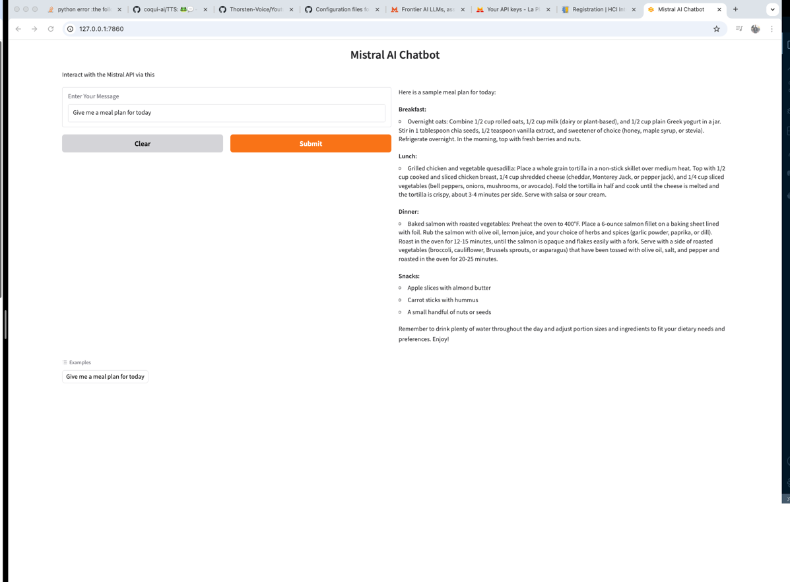

**Figure 1:** Mistral Ai Chatbot

* Once the story is generated or provided by the user, we utilize **Mistral AI** to create a compelling and contextually appropriate title. This ensures the title aligns with the theme and tone of the story. However, if the user submits their own story, they also have the option to supply a custom title instead of relying on AI-generated suggestions.
* After the story and its title are finalized, we leverage **Mistral AI** once more to segment the narrative into distinct scenes. These scenes serve as the foundation for the visual storytelling process and directly correspond to what the user will see in the final video output.
* Once the scenes are generated, we use **Mistral AI** to craft detailed and imaginative prompts tailored for **Stable Diffusion**. These prompts guide the image generation process, ensuring each scene is visually aligned with the narrative.
* For image generation, we use **Stable Image Core** from **Stability AI**—a powerful text-to-image model based on **Stable Diffusion** (Figure 2). Each scene prompt is sent to Stability AI, which returns high-quality, vivid images that visually represent the story. These images are then saved and prepared for further processing.

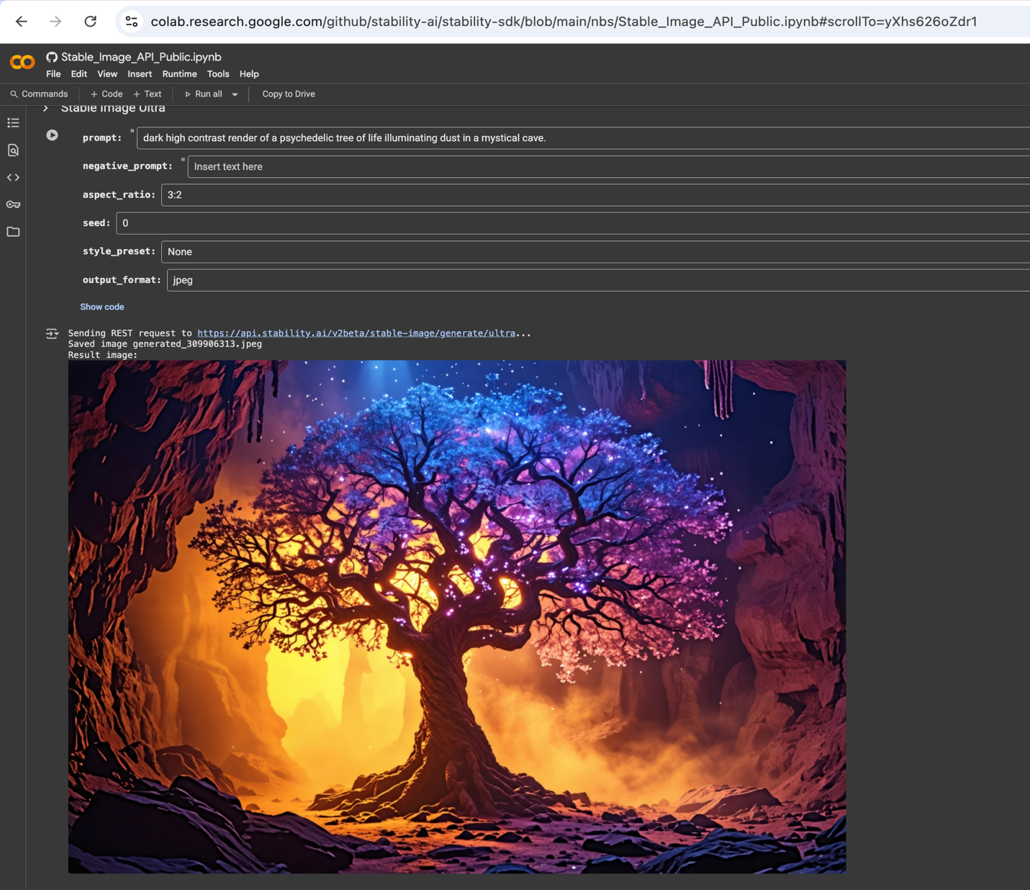

**Figure 2:** Stability AI Core

* Each generated image is passed to **Stability AI's image-to-video generation tool**, which animates the visuals to produce smooth, dynamic motion. This step ensures that the final output is a cohesive animated video rather than a static slideshow of frames.
* Next, we utilize the **Coqui TTS VITS model** (Figure 3) to generate high-quality audio narration. The full story—including the title and main content—is passed to the model, which produces natural-sounding speech to accompany the video.

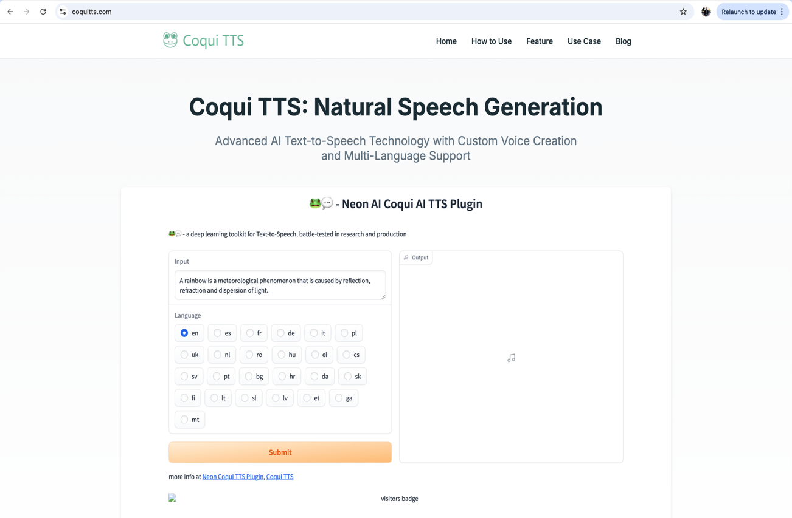

**Figure 3:** Coqui TTS

* Finally, we use python to combine the generated video scenes with the audio narration to produce the final video. Careful synchronization ensures that the visuals align with the pacing and length of the narration, resulting in a cohesive and immersive storytelling experience.

Backend

* For the backend of our web application, we use **FastAPI** (Figure 4), a modern, high-performance Python web framework designed for building APIs efficiently. FastAPI enables seamless communication between the frontend and the AI pipeline, handling user requests, managing WebSocket connections for real-time updates, and orchestrating the end-to-end story generation and video creation process.

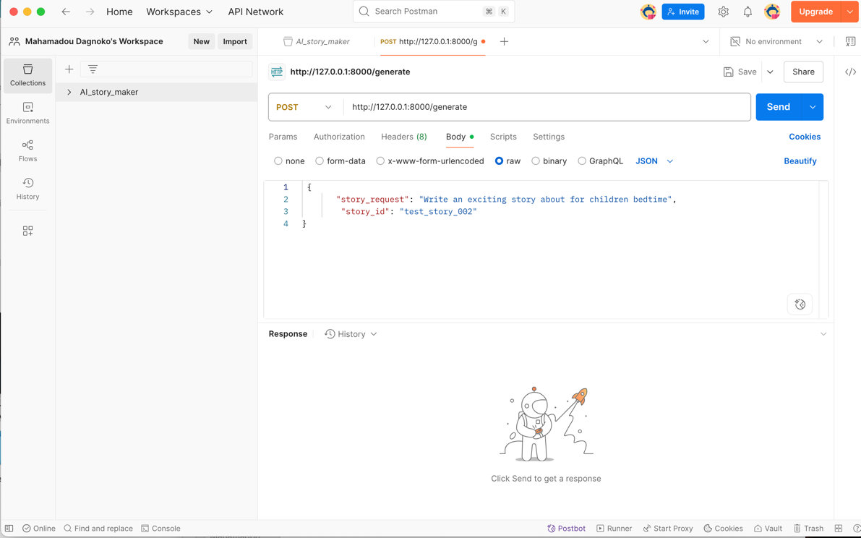

**Figure 4:** Postman running FastAPI

* We also use **Supabase**, an open-source backend-as-a-service platform, to securely store and manage our generated videos and audio files (Figure 5).

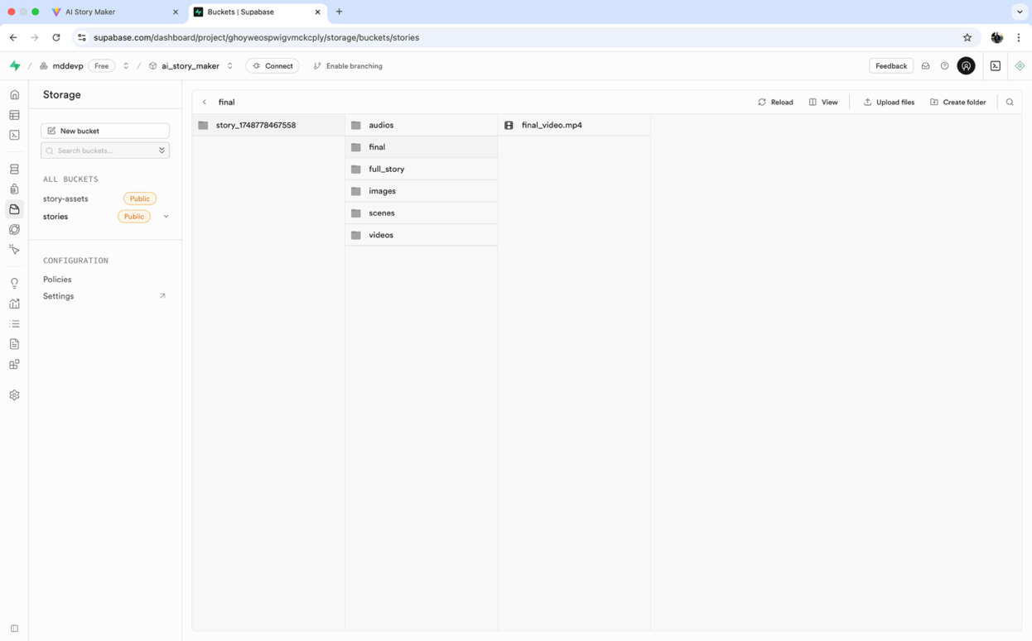

**Figure 5**: Supabase Storage

Frontend

We use **Vite + React** to build a modern, fast, and interactive user interface for our web application (Figure 6). **Vite** is a next-generation frontend build tool that offers lightning-fast development and optimized production builds. Paired with **React**, a popular JavaScript library for building user interfaces, this combination allows for a smooth and responsive user experience.

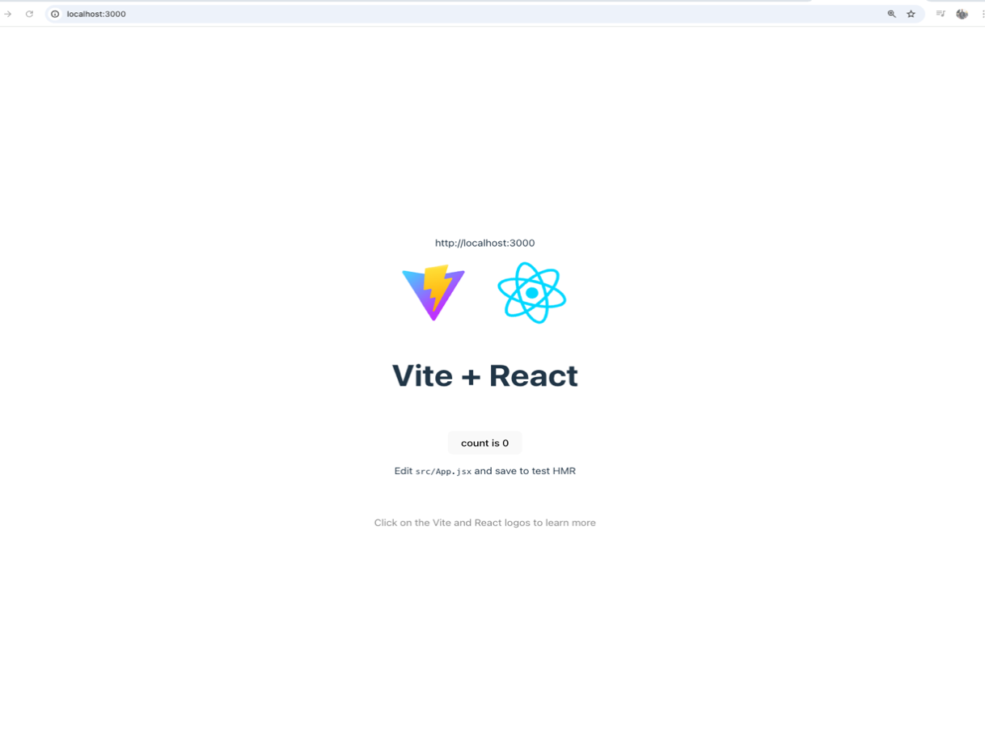

**Figure 6:**  Vite + React

Our application features four main pages:

1. **Home Page** – Introduces users to the platform and provides an entry point to start creating stories (Figure 7).



**Figure 7:** Home page

1. **Generate Page** – This page enables users to input a prompt or upload their own story to initiate the AI-driven generation process (Figure 8). When users toggle the option to enter their own story, they are provided with a field to input a custom story title (Figure 9). Upon clicking the **“Generate Now”** button, users receive real-time feedback on the progress through a dynamic progress bar (Figure 10). This live update is implemented using **WebSockets**, allowing seamless, bidirectional communication between the frontend and backend during story generation. After the generation is complete, a popup window appears allowing the user to preview the video and optionally download it(Figure 11).
2. 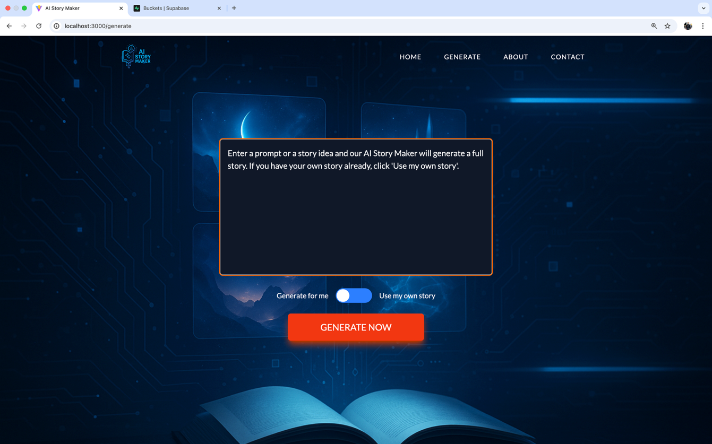

**Figure 8:** AI story generation

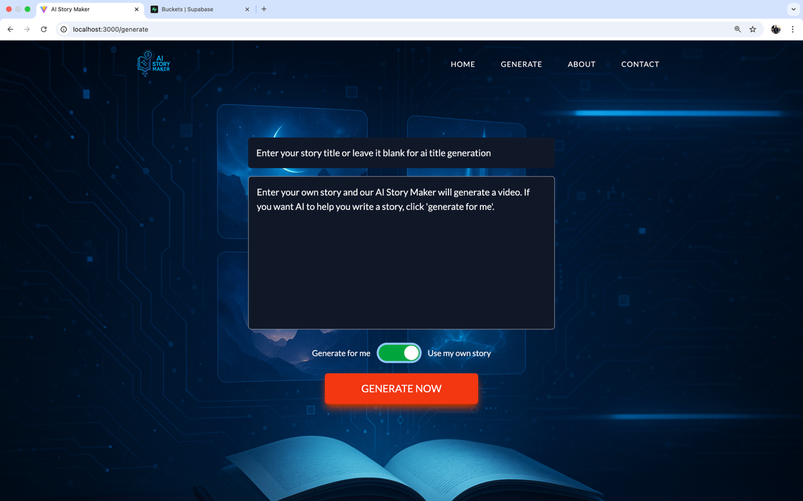

**Figure 9:** Personal Story generation

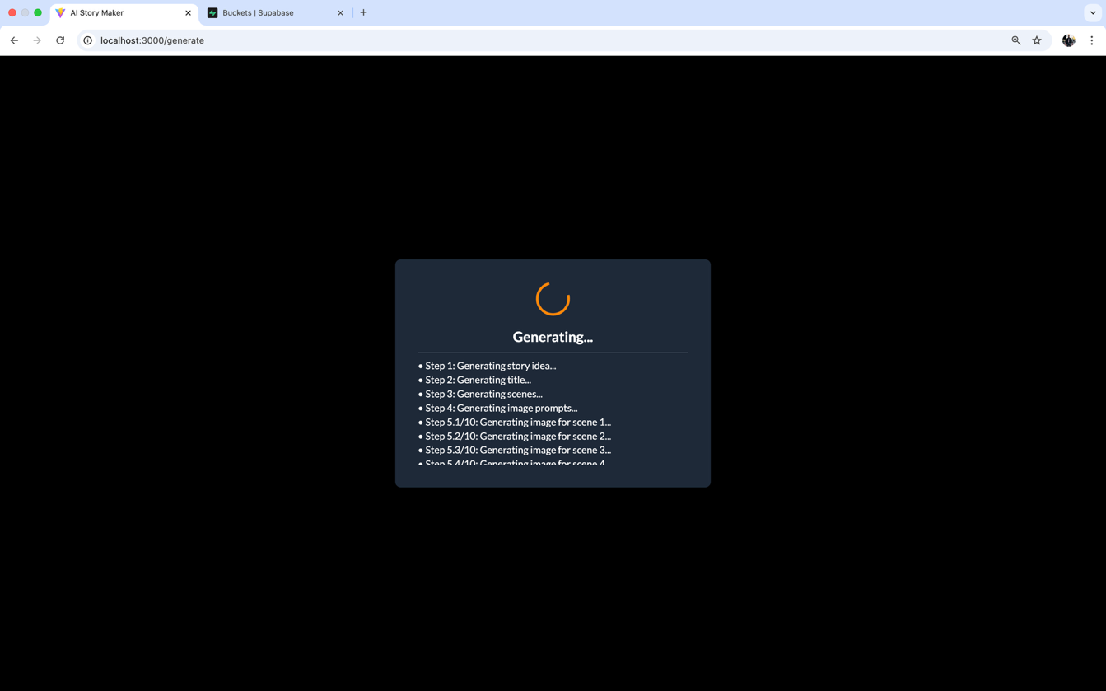

**Figure 10:** Progress pop up

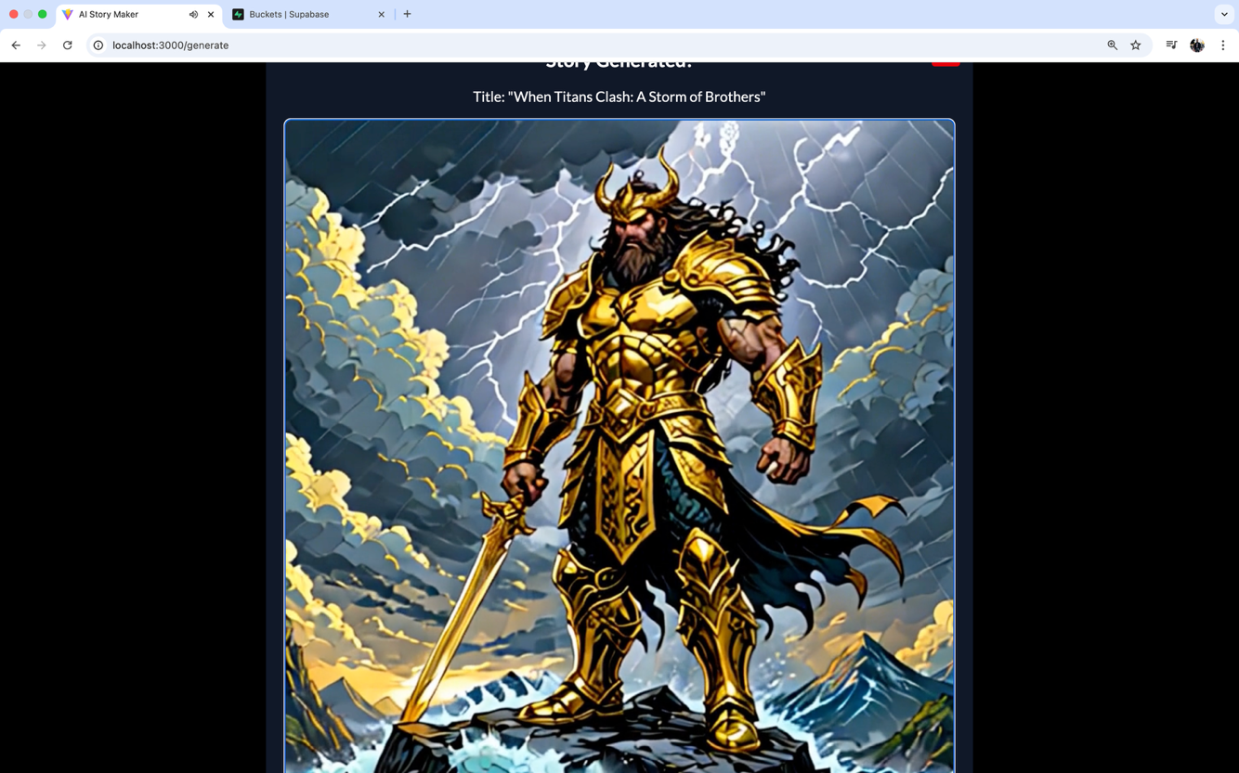

**Figure 11:** Video player

1. **About Page** – Describes the technologies and models used in building the application.

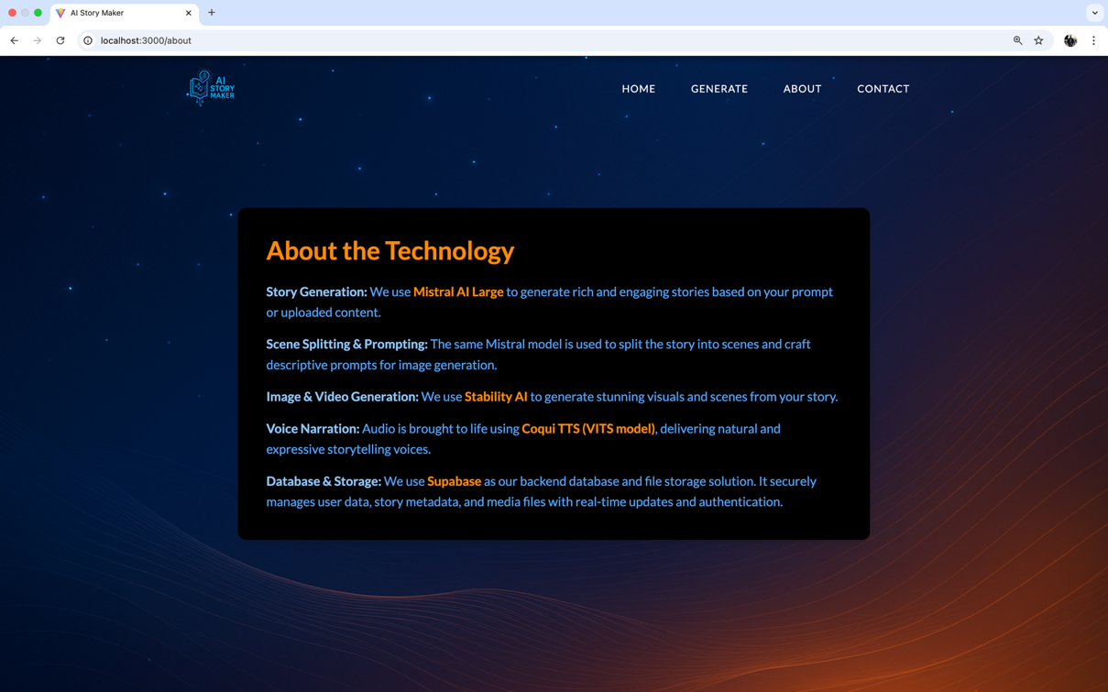

**Figure 12:** About page

1. **Contact Page** – Allows the user to contact the development team to address any inquiry they have.

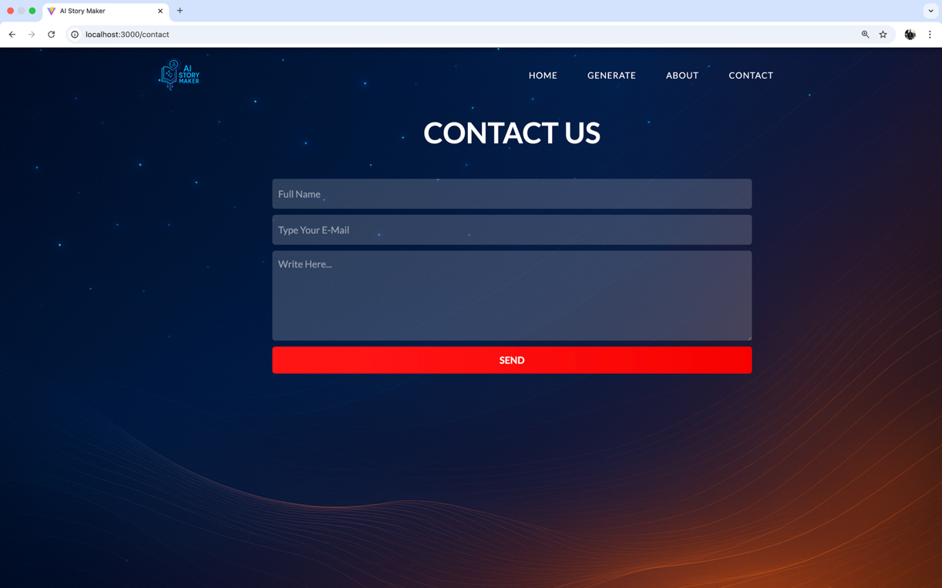

**Figure 13:** Contact page